DAD 220 Module Two Activity Template

Overview

Using the tables and SQL statements from the Module Two Activity Guidelines and Rubric, answer the questions below. Replace the bracketed text with your answers and any supporting screenshots.

- How many records are shown in the Employee table?

There are 5 records

- How many attributes are there in the Branches table?

There are 2 attributes

- Which attribute could be a primary key for the Employee table?

Employee_ID

- What is the maximum number of decimal places that can be stored in an employee’s Salary field?

2 decimals as indicated by Salary DECIMAL(7,2)

- What is the maximum number of decimal places that a Department_ID can have?

- Department_ID can’t have decimals as it is a SMALLINT.

- What three rules do tables obey?

Exactly one value per cell, no duplicate column names, and no duplicate rows

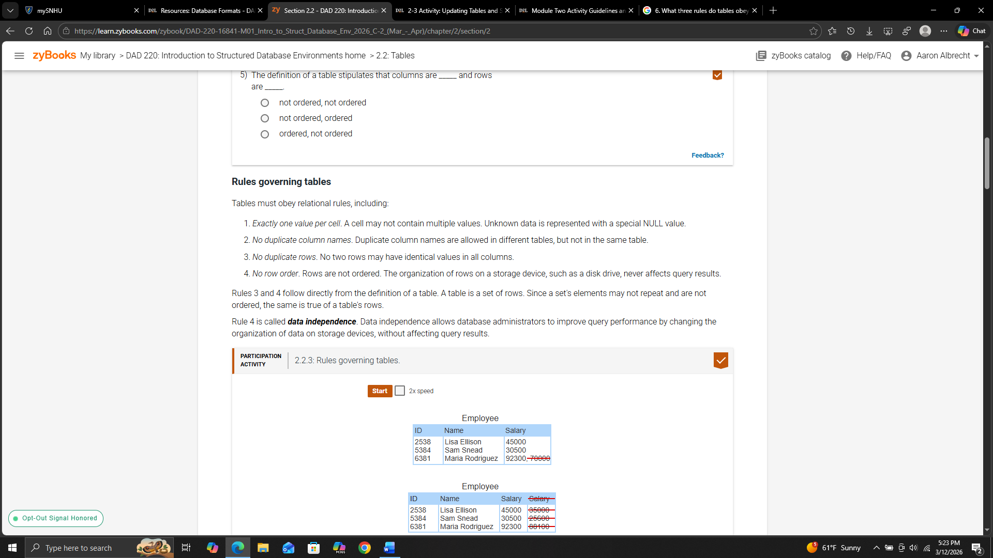
- What is the result of the following query?
  - Select sum(Salary) from Employee where Department_ID=3;

170000

- Identify the Employee ID or IDs that would be returned as a result of the following query.
  - Select * from Employee where Classification != 'Exempt';
    - Hint: True Null values will not return in the query.

101, 104

- What is the result of the following query?
  - Select max(Salary) from Employee;

90000

